**RAMAIAH**

**Institute of Technology**

**DEPARTMENT OF INFORMATION SCIENCE & ENGINEERING**

**RAMAIAH INSTITUTE OF TECHNOLOGY**

**(AUTONOMOUS INSTITUTE AFFILIATED TO VTU)**

**M. S. RAMAIAH NAGAR, M. S. R. I. T. POST, BANGALORE – 560054**

**2019-2020**

**RAMAIAH INSTITUTE OF TECHNOLOGY**

**(Autonomous Institute Affiliated to VTU)**

**EEG Data Visualization**

**A report submitted in partial fulfillment of the requirements**

**Of**

**Mini-Project (ISL64)**

**In**

**Sixth Semester**

**By**

|  |  |
| --- | --- |
| **1MS17IS051** | **Pavan Krishna** |
| **1MS17IS070** | **Nayan Deep** |
| **1MS17IS160** | **Gautam MG** |
|  |  |

**Under the guidance of**

**Dr. Lingaraju M**

Associate Professor

Dept. of ISE, RIT

**RAMAIAH INSTITUTE OF TECHNOLOGY**

**(Autonomous Institute Affiliated to VTU)**

**M. S. Ramaiah Nagar, M. S. R. I. T. Post, Bangalore – 560054**

### DEPARTMENT OF INFORMATION SCIENCE AND ENGINEERING



**RAMAIAH Institute of Technology**

**CERTIFICATE**

This is to certify that the project work entitled **“EEG Data Visualization ”** is a bonafide work carried out by **K S Pavan Krishna,Nayan Deep,Gautham MG** bearing **USN: 1MS17IS051, 1MS17IS070,1MS17IS160** in partial fulfillment of requirements of Mini-Project (ISL64) of Sixth Semester B.E. It is certified that all corrections/suggestions indicated for internal assessment have been incorporated in the report. The project has been approved as it satisfies the academic requirements in respect of project work prescribed by the above said course.

#### _________________ _________________

Signature of the Guide Signature of the HOD

**Dr. Lingaraju M Dr. Vijaya Kumar B P** Professor Professor and Head,Dept. of ISE, RIT, Dept. of ISE, RIT

Bangalore-54 Bangalore-54

Other Examiners

#### Name of the Examiners: Signature

**Acknowledgements**

This project has been an important milestone in our journey as engineers.

We would like to take this opportunity to thank the people who guided us throughout this very stimulating experience.

We are thankful to our principal **Dr. N V R Naidu** for providing us the facilities to carry out our project work. We extend our thanks to our **HOD, Dr. Vijay Kumar** **B.P, Professor and Head, Department of Information Science Engineering.**

We would especially wish to express our gratitude to our project guide,

**Prof. Lingaraju M sir** who offered us invaluable assistance, exemplary guidance and constant encouragement. We would also like to thank all the teaching and non-teaching staff for their contributions to this department.

1MS17IS070

1MS17IS051

1MS17IS160

.

## Abstract

Attention Deficit Hyperactivity Disorder (ADHD) are not able to maintain focus on a task for an appreciable period. The most common symptoms of ADHD are failing to pay close attention, making careless errors, and having difficulty sustaining attention to task or play activities. Our project is to easily determine from the raw EEG data whether a child is suffering from ADHD or not by analyzing the EEG data in MATLAB. EEG stands for Electroencephalography, and it measures the electrical activity in our brain from the synaptic excitations of our neurons.

A website is created which takes the EEG data and saves it in the database then using MATLAB the data is processed. First we transform the EEG data from Time Domain to Frequency Domain for better analysis and then we determine peak alpha to determine the presence of ADHD in the child.

**Contents**

**1 Introduction** **1**

1.1 Motivation 1

1.2 Scope 1

1.3 Objectives 1

1.4 Proposed Model 1

1.5 Organisation of Report 1

**2 Literature Review** **2**

**3 System Analysis and Design** **3**

**4 Modelling and Implementation** **4**

**5 Testing, Results and Discussion** **5**

**6 Conclusion and Future Work** **6**

**References 7**

**List of Figures**

* **Figure 1 :- System Analysis Flowchart**
* **Figure 2 :- Modelling Flowchart**
* **Figure 3 :- Output Spectrum**

**Chapter 1**

# Introduction

## Motivation:

**According to the literature survey and surveys done by the recognized organizations, many facts were found out. The prime motivations of this project are as follows:**

* Over 5 million children in this country are diagnosed with attention deficit hyperactivity disorder (ADHD) and of those children, about 3 million are medicated each year.
* It is a common problem seen in about 3 to 10 per cent of school age children. It is 4-6 times commoner in boys as compared to girls (l, 4).
* According to an ASSOCHAM survey, the number of such cases in the country has gone up from 4% in 2005 to 11% in 2011.
* In a survey undertaken about 6 years ago that covered 2,300 school children, it was found that 4-5% of city children in the age group of 6-9 years were suffering from ADHD.
* Several studies estimated the prevalence of ADHD, in USA 4-8%, Korea 7.6% to 9.5%, India 20%, and Emirates 29.7% in United Arab8-11.
* In many cases this disorder goes totally undiagnosed.
  1. **Scope:**

In relation with EEG signals, a lot of works has been done to find the significant difference between the neural activity of ADHD and normal subjects by using different methodologies. This project is mainly designed to predict the probable region of brain that shows abnormality due to ADHD syndrome. In this process, frequency characteristics of ADHD and normal subjects are extracted and compared to differentiate between the each. Several analyses are conducted to find out the probable region of abnormality and finally, 3-D plotting is performed for ease of visualization.

## Objectives:

This project work has its own social importance and if further proceeded for research would:

* Help in proper detection of the abnormality and assists for further treatment plan. Since, several studies estimated the prevalence of ADHD, in USA 4-8%, Korea 7.6% to 9.5%, India 20%, and Emirates 29.7% in United Arab8-11 and every 3 out of 5 children in the world are affected by this syndrome.
* Supports cognitive trainers to improvise the behavior of children with ADHD syndrome. This is done by periodically evaluating the improvements in kid’s academic performance and day-to-day activities.
* The cost involved to detect ADHD syndrome as per the literature is significantly high, whereas, detection of the same as proposed in the project is cost-effective. Therefore, this could be brought out as a product.
* EEG readings might be used to diagnose ADHD syndrome and can also be used by brain trainers to measure the effect of cognitive training.

We have predicted the probable region of abnormality and electrode positions that could be considered for detecting the abnormality. The researchers and specialists in medical field can take this further and accurately detect the exact region of abnormality which might help in diagnosing the syndrome.

## 

## Proposed Model:

* EEG data is collected from electrodes attached to the subject’s scalp, and MEG data is collected via sensors located inside the EEG rigid helmet
* When we take the EEG data first we convert the data from time domain to frequency domain
* Then we apply the Fourier transform to the whole data Any periodic waveform can be produced by adding up a series of sin waves of the appropriate frequency and amplitude. The FFT looks at a complex waveform and calculates those frequencies and amplitudes. The result is a new curve which plots amplitude vs frequency. Thus, it transforms the signal from the time domain into the frequency domain.
* Then we average the power from 8-12 Hz (the "alpha band") and make a topographical map of the distribution of this power.
* We then quantify this part . i.e. square it, to get amplitude and better peaks which can be easily viewed
* Then we plot the spectrum of all channel data on the scalp
* Physically analyse the image and draw a conclusion

## Organization of Report

In order to explain the developed system, the following sections are covered:

* **Literature Review** describes the study of the existing systems and techniques taken into account prior to development of the proposed system.
* **System Analysis and Design** provides a detailed walk through of the software engineering methodology adopted to implement the model, an overview of the system and the modules incorporated into the system
* **Modelling and Implementation** provides a deeper insight into the working of the model. The various modules and their interactions are depicted using relevant descriptive diagrams.
* **Testing** the model to ensure bug/error free model along with the **Results** obtained. **Discussion** then provides detailed analysis on quality assurance measures.
* **Conclusion** about the Results obtained after successfully running the model and **Future Scope** of the model is highlighted.

**Chapter 2**

# Literature Review : Some examples of existing technologies:

**A virtual-Reality based Neurofeedback Game Framework For Depression Rehabilitation using pervasive Three Electrode EEG collector:**

Depression is mainly treated with anti-depressant drugs usually assisted by non-medication treatments, such as psychotherapy and physical therapy. These treatments are very expensive and anti-depressant drugs are not a permanent solution. In this paper, a new virtual-reality based neurofeedback game framework for rehabilitation, which would increase patients’ motivation for therapy, and lower the cost for both patients and therapists. In this framework, patients’ EEG data are pervasively recorded using an innovative three-electrode EEG collector. Then the data are processed and calculated into feedback features, and finally represented back to patients through virtual-reality games in real-time.

**Quantitative EEG Evaluation Of Multimedia Intervention Program for ADHD Children:**

This paper deals with a quantitative evaluation for the therapeutic efficacy of a multimedia intervention program applied to ADHD children to improve their cognitive awareness. The multimedia intervention program consisted of 3 levels in which children can carry out several tasks for focusing attention, sustaining attention, and selective attention. The program was made up of 13 sessions over 24 weeks. Each session took 20 minutes. Four ADHD children between ages from 10 to 12 participated in the program. All of sessions were recorded by 8 channel EEG electrodes which were capped in prefrontal lobe.

This paper chose theta wave as an evaluation measure for therapeutic improvement.

**Chapter 3**

# System Analysis and Design

Our system is designed to facilitate the exploration of EEG data with respect to the identiﬁcation of functionally important time- frequency patterns. The choices made during the development of our system were designed to enhance the application’s intuitive usability while maintaining ﬂexibility and functionality.

Our system begins with the user loading EEGdata. Each EEG sensor is displayed as a sphere in a 3D visualization. In this case, each sensor is rigidly registered to the structural MRI data. Next, the user sets the upper and lower frequencies to parametrize time-frequency decompositions. The user then explores both the raw time series data as well as its spectral representation.

At this time, the user sets a query to issue to the system; this may be created from a time series present in the EEG collection or through a brushable canvas. Once the query is deﬁned ,

cross-correlograms are computed between the query and the time-frequency planes derived from each EEG electrode .Each cross-correlogram is an image representing the cross-correlation

statistics of the query and the time-frequency plane being analyzed. The resulting images are then ﬁltered to provide sensitivity to shifts in both frequency and time. After ﬁltering, the maximum correlations are displayed by coloring each sensor by its similarity with the query.

Higher correlation values are represented in the ﬁnal visualization by more saturated color than lower values. In this way,coordinated areas of the brain, as seen by the sensor collection, are

highlighted and may inﬂuence future processing and analysis parameters

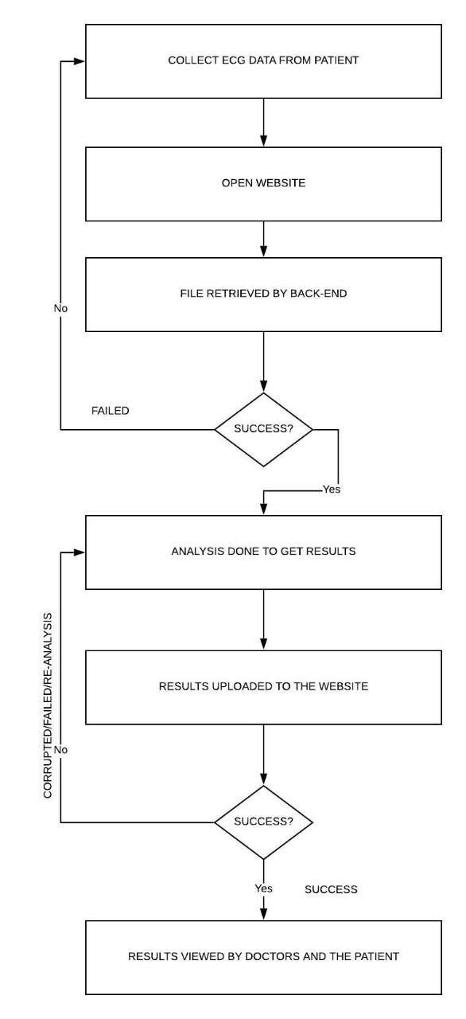

**Chapter 4**

# Modelling and Implementation

EEG device which is a 24 channel digital EEG

machine having the A/D conversion of 16bits with the sampling frequency of 256 Hz.

This depicts the flowchart of the proposed

methodology

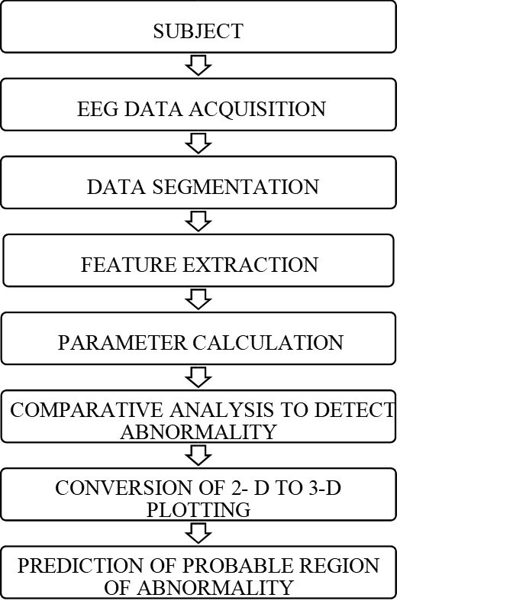

**Longitudinal Bipolar montage**

During the data acquisition, many noises get added to the actual data like Scalp impedance, Physical movement of electrodes, chewing, Blinking, AC line current, video monitors, AC light, Pagers etc.

In order to minimize this noise, several measureswere also taken like: Hair, Hair products, sweat and other scalp debris are the sources of impedance. To minimize this, scalp abrasions were used and conductive gel was applied; In order to reduce the environmental noises, acoustically and electrically shielded cables were used; Notch filter is used to remove the power line interference and to reduce the distortion of signal of interest.

**PROTOCOL USED**

A common protocol of eyes close and eyes open isused which was done in alternating sets of two with varying time record length which helps in studying the alpha wave activity.The second step in protocol was visual cue whichconsisted of some common aspects such as colors,

numbers, and animals which are identifiable by bothnormal and abnormal subjects. Each of the slides had the duration of 2 seconds and making total of 46 seconds of EEG data.

The next step was motor activity, where all the subjects were asked to arrange the spoons and hand it over to their care taker.

**DATA SEGMENTATION**

The data was selected manually with minimumredundancy. The electrode positions were selected based on the interest of our study. The data segmentation is done manually using markers during acquisition of data. The markers were inserted based on events and timings during the data acquisition.

**Feature extraction**

Different features of EEG signals such as frequency bands (alpha, beta, delta and theta), energy, power and statistical parameters such as mean, SD and variance were calculated and following procedure was adopted.The EEG signal should be in time domain. FFT of EEG data provides the frequency domain representation of the time domain EEG signal. A specific band pass filter belonging to the frequency range of Alpha, Beta, Delta and Theta bands were used. The frequency ranges are: Delta band: 0.0 – 4.0 Hz; Theta band: 4.0 – 8.0 Hz; Alpha band: 8.0 – 12.0Hz; Beta band: 12.0 – 25.0 Hz. After specifying the frequency ranges and filtering the data by using FFT algorithm energy for corresponding amplitude values for each sample of each event and of each electrode position were computed. The frequencies ranges delta, theta, alpha and beta provide information concerning the active state of various regions of the brain. Analyses adopted were: Single map analysis- In single map analysis the amplitude levels of the EEG data is obtained; Frequency map analysis- obtained data is converted from 2D to 3D plot; Frequency tables- Frequency table represents the absolute power and relative power percentage. The probable affected region can be predicted using neural network algorithm.

**Chapter 5**

# Testing, Results and Discussion

## 5.1 Testing:

This project is made using HTML, JavaScript, MySQL, MATLAB. It is developed for hospitals. First a dataset is uploaded to the website. Then the uploaded data is loaded in MATLAB and processed to find the peak alpha. Then we plot the spectrum of all channel on the scalp. Then the doctor manually analyzes the image and draws a conclusion.

## 5.2 Results:

After testing we obtained the following spectrum:

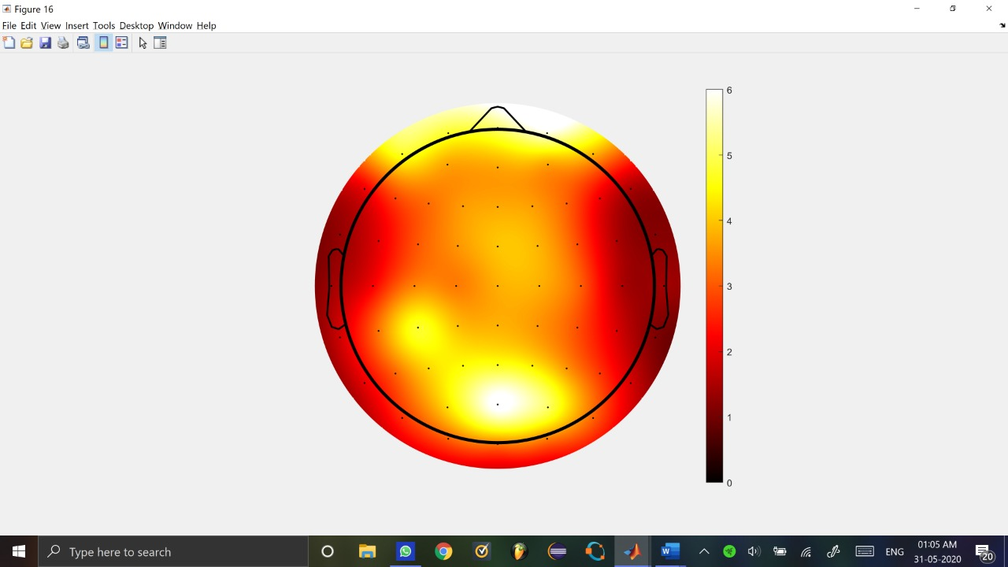

## 5.3 Discussion:

As the past 75 years will attest, finding a simple diagnostic measure for ADHD (i.e., behavioral, cognitive, etiologic, neurophysiologic, or neurobiologic) has not been possible and such a measure may not exist at all. Needless to say, we believe that EEG is ready to serve as tools to diagnose or aide in the diagnosis of ADHD.

**Chapter 6**

# Conclusion and Future Work

* This project can further be modified to have limitless potential in the future. For example, if the technology improves the data collection and the analysis can be done by the patient itself
* The MATLAB analysis can be implemented into the website to get a seamless experience
* Create an mobile application for the same
* Get doctors and patients from multiple countries to interact in a forum in a separate tab in the website or the mobile application if created
* Create an api for the same so that it can embedded into already existing electrical medical equipment so that reduces the rate of error and simplifies the way to use it

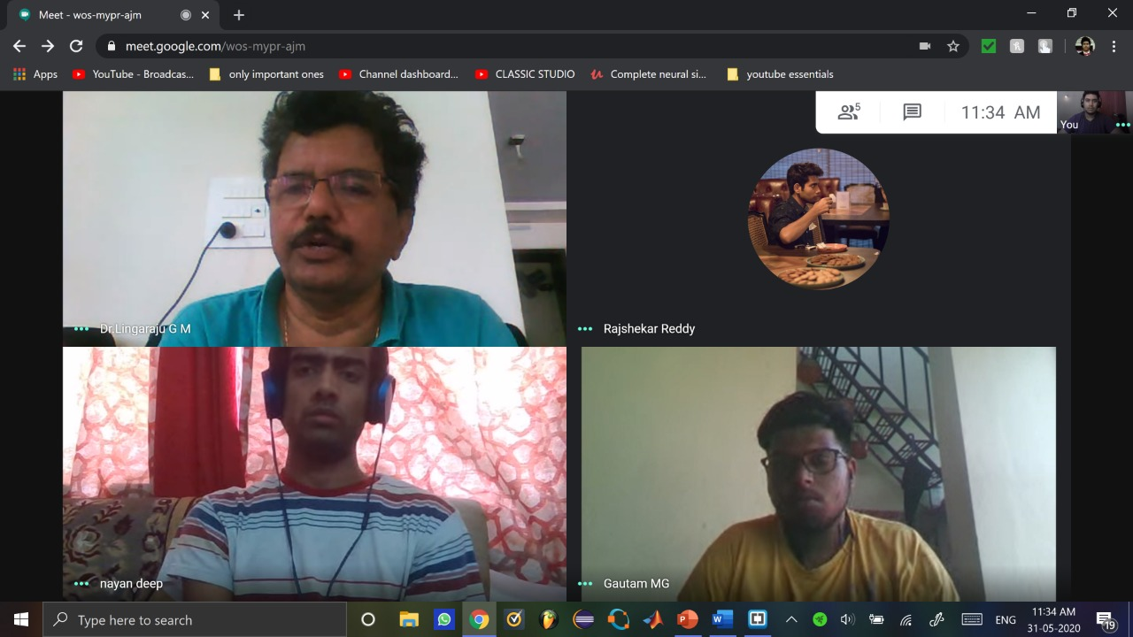

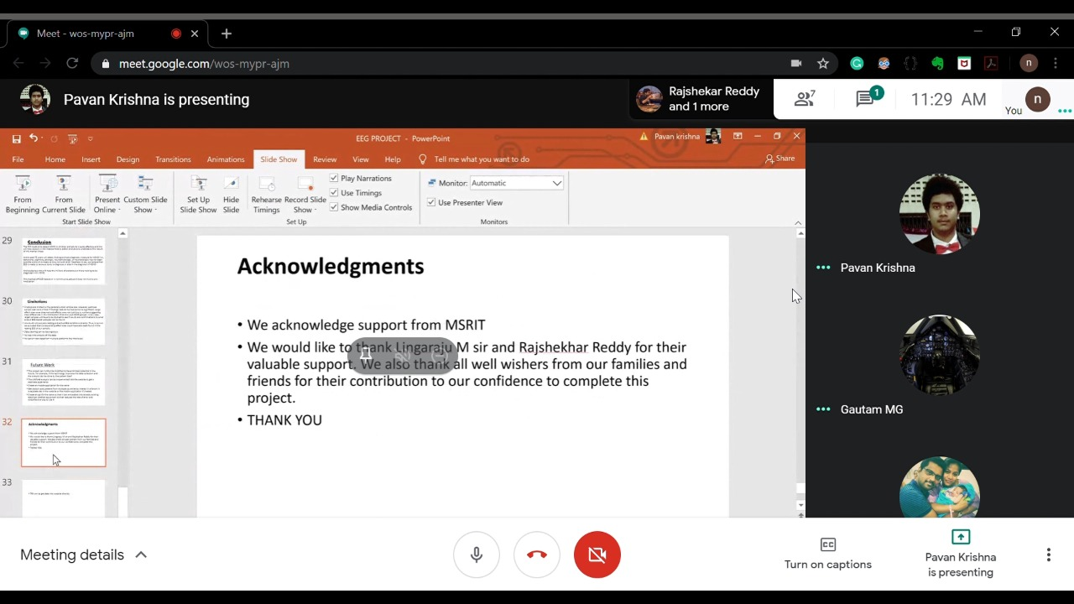

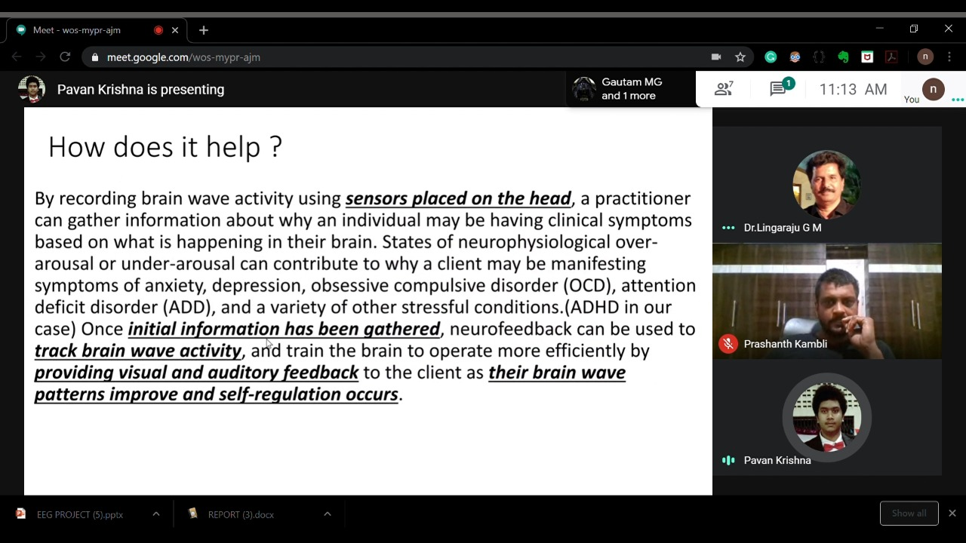

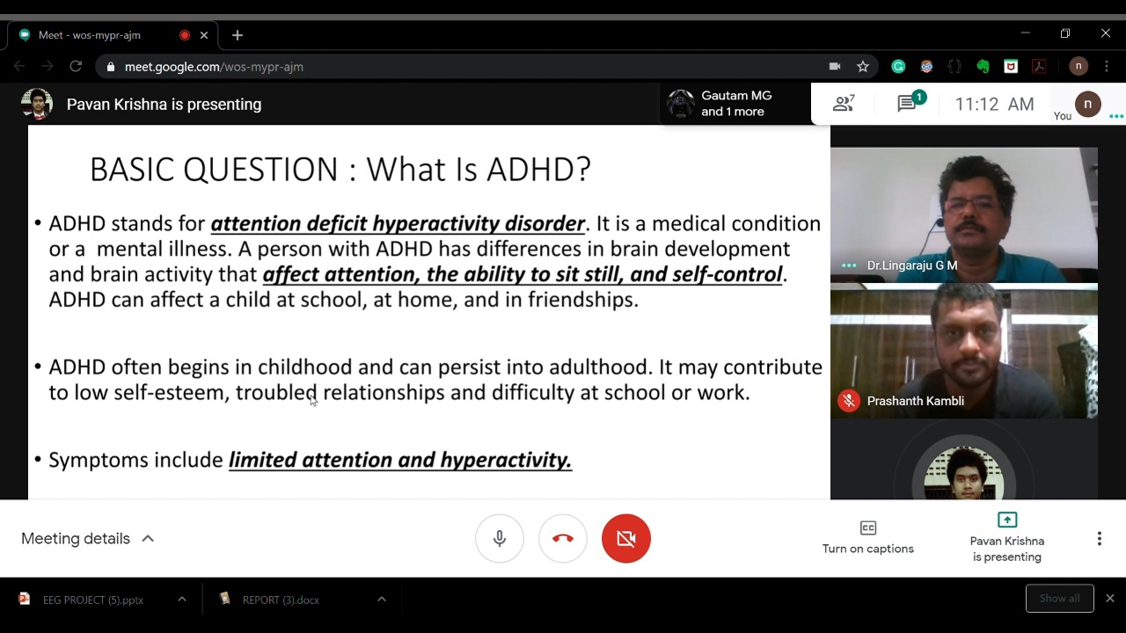

**Bibliography**

1. L. Mayaud, M. Congedo, A. van Laghenhove et al., “A comparison of recording modalities of P300 Event Related Potentials (ERP) for Brain-Computer Interface (BCI) paradigm,” *Clinical Neurophysiology*, vol. 43, no. 4, pp. 217–227, 2013.View at: [Publisher Site](https://doi.org/10.1016/j.neucli.2013.06.002) | [Google Scholar](https://scholar.google.com/scholar_lookup?title=A%20comparison%20of%20recording%20modalities%20of%20P300%20Event%20Related%20Potentials%20(ERP)%20for%20Brain-Computer%20Interface%20(BCI)%20paradigm&author=L.%20Mayaud&author=M.%20Congedo&author=A.%20van%20Laghenhove%20et%20al.&publication_year=2013)
2. X.-Y. Wang, J. Jin, Y. Zhang et al., “Brain control: human-computer integration control based on brain-computer interface approach,” *Acta Automatica Sinica*, vol. 39, no. 3, pp. 208–221, 2013.View at: [Google Scholar](https://scholar.google.com/scholar_lookup?title=Brain%20control:%20human-computer%20integration%20control%20based%20on%20brain-computer%20interface%20approach&author=X.-Y.%20Wang&author=J.%20Jin&author=Y.%20Zhang%20et%20al.&publication_year=2013)
3. G. Al-Hudhud, “Affective command-based control system integrating brain signals in commands control systems,” *Computers in Human Behavior*, vol. 30, pp. 535–541, 2014.View at: [Publisher Site](https://doi.org/10.1016/j.chb.2013.06.038) | [Google Scholar](https://scholar.google.com/scholar_lookup?title=Affective%20command-based%20control%20system%20integrating%20brain%20signals%20in%20commands%20control%20systems&author=G.%20Al-Hudhud&publication_year=2014)
4. J. L. S. Blasco, E. Iáñez, A. Úbeda, and J. M. Azorín, “Visual evoked potential-based brain-machine interface applications to assist disabled people,” *Expert Systems with Applications*, vol. 39, no. 9, pp. 7908–7918, 2012.View at: [Publisher Site](https://doi.org/10.1016/j.eswa.2012.01.110) | [Google Scholar](https://scholar.google.com/scholar_lookup?title=Visual%20evoked%20potential-based%20brain-machine%20interface%20applications%20to%20assist%20disabled%20people&author=J.%20L.%20S.%20Blasco&author=E.%20I%C3%A1%C3%B1ez&author=A.%20%C3%9Abeda&author=&author=J.%20M.%20Azor%C3%ADn&publication_year=2012)
5. H. Cecotti, “Spelling with non-invasive brain-computer interfaces—current and future trends,” *Journal of Physiology*, vol. 105, no. 1–3, pp. 106–114, 2011.View at: [Publisher Site](https://doi.org/10.1016/j.jphysparis.2011.08.003) | [Google Scholar](https://scholar.google.com/scholar_lookup?title=Spelling%20with%20non-invasive%20brain-computer%20interfaces%E2%80%94current%20and%20future%20trends&author=H.%20Cecotti&publication_year=2011)
6. I. S. Kotchetkov, B. Y. Hwang, G. Appelboom, C. P. Kellner, and E. S. Connolly Jr., “Brain-computer interfaces: military, neurosurgical, and ethical perspective,” *Neurosurgical Focus*, vol. 28, no. 5, article E25, 2010.View at: [Google Scholar](https://scholar.google.com/scholar_lookup?title=Brain-computer%20interfaces:%20military,%20neurosurgical,%20and%20ethical%20perspective&author=I.%20S.%20Kotchetkov&author=B.%20Y.%20Hwang&author=G.%20Appelboom&author=C.%20P.%20Kellner&author=&author=E.%20S.%20Connolly%20Jr.&publication_year=2010)
7. E. D. Übeyli, “Statistics over features: EEG signals analysis,” *Computers in Biology and Medicine*, vol. 39, no. 8, pp. 733–741, 2009.View at: [Publisher Site](https://doi.org/10.1016/j.compbiomed.2009.06.001) | [Google Scholar](https://scholar.google.com/scholar_lookup?title=Statistics%20over%20features:%20EEG%20signals%20analysis&author=E.%20D.%20%C3%9Cbeyli&publication_year=2009)
8. R. Agarwal, J. Gotman, D. Flanagan, and B. Rosenblatt, “Automatic EEG analysis during long-term monitoring in the ICU,” *Electroencephalography and Clinical Neurophysiology*, vol. 107, no. 1, pp. 44–58, 1998.View at: [Publisher Site](https://doi.org/10.1016/S0013-4694(98)00009-1) | [Google Scholar](https://scholar.google.com/scholar_lookup?title=Automatic%20EEG%20analysis%20during%20long-term%20monitoring%20in%20the%20ICU&author=R.%20Agarwal&author=J.%20Gotman&author=D.%20Flanagan&author=&author=B.%20Rosenblatt&publication_year=1998)
9. A. Meyer-Lindenberg, “The evolution of complexity in human brain development: an EEG study,” *Electroencephalography and Clinical Neurophysiology*, vol. 99, no. 5, pp. 405–411, 1996.View at: [Publisher Site](https://doi.org/10.1016/S0013-4694(96)95699-0) | [Google Scholar](https://scholar.google.com/scholar_lookup?title=The%20evolution%20of%20complexity%20in%20human%20brain%20development:%20an%20EEG%20study&author=A.%20Meyer-Lindenberg&publication_year=1996)